

CP5046: ICT Project 1

ROMASHKA

# Project Audit

# Lecturer: Laura Antochi

**Team Members:**

Anastasia Verchak ID: 13446694

Charanpreet Kaur ID: 13543377

Harshitha Paderu ID: 13539782

Abstract

The primary goal of this project is to develop a responsive website with high efficiency, learnability, memorability and safety; for the staff, students/parents of the Russian language school Romashka. During the alpha release, our team has solved a lot of different issues connected with different project areas started from technology learning and went through the project management, development and design. Unfortunately, not all user stories from Alpha have been delivered to the customer because of a couple of technical issues which appeared during that stage. This audit report is describing Alpha stage development in details, as well as tools and instruments which were used for that and planning for the next two stages: beta and final.

Alpha release

|  |  |
| --- | --- |
| **User story** | **Time frame** |
| Home page | 01/01/19 – 28/01/19 |
| Login page |
| Register page |
| Dashboard |

This stage contains 3 user stories for implementing. This quantity is because of the list of skills which our team have not had before the project has been started. List of that skills is attached below:

|  |  |
| --- | --- |
| **Developer’s Learning Tools** | **Time Frame** |
| Bootstrap | 17/12/18 - 01/01/19 |
| Dreamweaver |
| PHP |

|  |  |
| --- | --- |
| **Project Manager’s Learning Tools** | **Time Frame** |
| Project Management Tools | 17/12/18 - 01/01/19 |

As could be seen, the Alpha stage was mainly about a learning and team collaboration which is extremely important for the next two stages of project development. After a long period, full of research and study, the team found that an implementing of Dashboard user story could have several issues, connected with the difficulties of developing and structure of the dashboard page. After a long discussion, as internal with the team and as external with the customer, the decision was made:

* Move user story Dashboard to the Beta release
* Find external service which provides all appropriate sources for delivering customer’s requirements.

As external service, Moodle platform was chosen.

Moodle has a free version, which allows creating an educational platform for 50 users and other different bonuses which are essential for the customer.

During the account registration, several obstacles were accused. Unfortunately, Moodle technical support has not responded yet for teams’ requests. That is the main reason why this user story has been moved to the beta. The client acceptance form is attached to this report as ClientAcceptationForm.pdf and had been signed by the client.

Rest of user stories were delivered according to plan, what could be seen in that audit report below.

|  |
| --- |
| User story: |
|  |
| Prototype 1 |
|  |
| Prototype 2: front end design |
|  |
| Front end |
|  |

# Home pageRequirements:

* The Home page has to be responsible
* Background images have to change dynamically
* Buttons Facebook, Linkedin, Instagram have to be connected with appropriate accounts in social media
* Button "Learn more" is linked with "Why we" page

All requirements, except the dynamic background, have been developed. Results and comments from the customer could be found in AlphaTestReport.pdf

|  |
| --- |
| User story |
|  |
| Prototype 1 |
|  |
| Prototype 2: Front end |
|  |
| Front end |
|  |

# Login page

## Requirements:

* After clicking on the button Login, the user has to get access to his profile
* Login through social media accounts has to be provided if the user has an appropriate account
* After clicking to the button Home and to the logo, the user will see the Home Page

All requirements, except login through social media, were developed successfully. Social media login is a part of the beta release. However, a bug was found here. All information could be found at the attached file AlphaTestReport.pdf

|  |
| --- |
| User story |
|  |
| Prototype 1 |
|  |
| Prototype 2: Front end |
|  |
| Front end |
|  |

# Registration page

## Requirements:

After clicking to the button Register, the user will be registered in the database, receive confirmation on an email, which was entered before, and has access to the profile and could choose subjects for studying and pay his fees.

All requirements were delivered to the customer, however, the customer has couple of comments according the design of the page which could be found at the attached file AlphaTestReport.pdf

## Individual contribution

|  |  |  |
| --- | --- | --- |
| **Name** | **Project role(s)** | **Individual contributions** |
| Anastasia Verchak | Project manager, tester, designer | * Client agreement * Prototypes * Communication with the client * White box testing * Project management tools * Documentation * Client testing acceptation form * Client acceptation form * Front end design * Final report and presentation |
| Charanpreet Kaur | Developer | * Configuration management * Front-end development |
| Harshitha Paderu | Developer | * Burn down and velocity charts * Steps for new member to setup database and hosting environment * Development tools - phpmyadmin, hosting environment - WinSCP * Back end development |

## Alpha release problems:

* Github tool has to be replace for another tool because of the serious of problems which appeared during that stage. Team had have technical problems with the using of desktop version of the program. Additional research and setup are required.
* Login page and Registration page have a problem with alignment of image. This problem was documented as a bug and would be fixed at the Beta.

## Alpha release conclusion

Alpha release was proper tested and accepted by the client. All changes were documented and signed by the both sides.

|  |  |
| --- | --- |
| **File** | **Comments** |
| ClientAcceptance.pdf | Signed and accepted planning of alpha and beta |
| AlphaTestReport.pdf | Signed by the client client testing report for alpha release. |
| RLSR_001, RLSR_002, RLSR_003, RLSR_006 | Test’s reports for every user story from Alpha |

# Beta release proposal

According to the results of Alpha release, new Beta plan had been created and accepted by the both sides.

|  |  |  |  |
| --- | --- | --- | --- |
| Title | Description | Client Priority | Time estimate (days) |
| Bug fixing | See AlphaTestReport.pdf | 10 | 5 |
| Confirmation page | presents the total amount to be paid | 20 | 5 |
| Payment page | process the payment | 20 | 5 |
| Subject Selection page | Students can enroll by choosing the subjects for the first time and confirm their enrollment | 20 | 5 |
| Edit Selection page | Edit the choices of subjects (withdrawing, changing of subjects) | 20 | 5 |
| Dashboard | Student has an access to his study activities | 10 | 5 |
| Contact us page | Access to the contact details of the school to find its location, phone number for any queries. | 20 | 2 |
| Why we page | Access to the information about the school involving teaching programs, events ,etc. | 20 | 5 |

* Gantt chart could be found at the attached file GanttChart.pdf
* WBS diagram could be found at the attached file Romashka_WBS.jpg

# CHANGES FROM ALPHA RELEASE

## Migrating to Moodle:

Due to complications and meeting deadlines, the User Story- Dashboard in Alpha release has now been moved to Beta Release and will be hosted by Moodle.

What is Moodle?

Moodle is a Learning Management System, designed for instructors, administrators and students to create their own personalised learning environments.

The advantage of Moodle is that it is an open source software available under the GNU Public License and can be simply installed onto the web server. It is developed in Linux using Apache, MySQL and PHP.

The hardware requirements for Moodle are:

Disk Space- 200MB for the code and minimum of 5GB to store content.

Processor- 2GHz dual core is recommended.

Memory- 1GB or more is recommended.

After thorough research, it was decided that Moodle is the best suited LMS for this project because of a number of benefits it has.

In Moodle, a Dashboard is available for students to check daily notifications when course contents are added, the information about enrolled subjects and the instructors of the respective courses.

This feature is the most desired feature for the project ‘Romashka’- as it distinguishes it from other Language school websites.

The following figure shows Moodle’s Student View:

An interesting feature provided by Moodle is that students can search within their courses the discussions had with peers or teachers. Any virtual classroom sessions conducted are recorded and the chat histories are available for students to review them whenever the need be.

Moodle allows random and automatic allocation of students into groups. The groups can be edited only by the teachers.

Moodle provides an extra feature called the Moodle Community Hub where students or instructors can access a location to share ideas or resources with peers, they can join in with communities hosted by other websites and yet is secure and can be set to be controlled only by the admin.

The assignments are submitted in a similar fashion but in Moodle, the assignments are saved as drafts if the student missed to click the submit button and closes the window.

## Burn-down chart

The Burndown chart is used to track the progress of the project that is well underway.

This chart represents the progress for the Alpha Release of this progress and the analysis will also help in managing the progress of the Beta and the Final Releases.

In this chart, on the X-Axis are the Number of Days that were allocated to all the User Stories that were planned in Alpha, which was 30. And on the Y-Axis are typically the User Stories (or the work that was to be done) to complete Alpha Release Successfully.

The User Stories and the days allocated in Alpha are shown in the table below:

|  |  |  |
| --- | --- | --- |
| **Alpha User Stories** | **Days Allocated** | **Status** |
| Login | 10 | Completed |
| Home Page | 5 | Completed |
| Registration | 3 | Completed |
| Dashboard | 5 | In Progress |
| Contact Us | 2 | In Progress |
| About Us | 5 | In Progress |

As it can be seen, some of the user stories could not be completed as planned and hence had to be moved to Beta Release.

Since the Alpha phase of this project also coincided with learning of the tools, setting up of the database and host environment for client testing, the completion took longer than planned.

This lag is represented by the blue line of the Burndown Chart.

For the Beta and Final Releases, it is planned to keep the blue line under the estimation line and get back on track with the project!

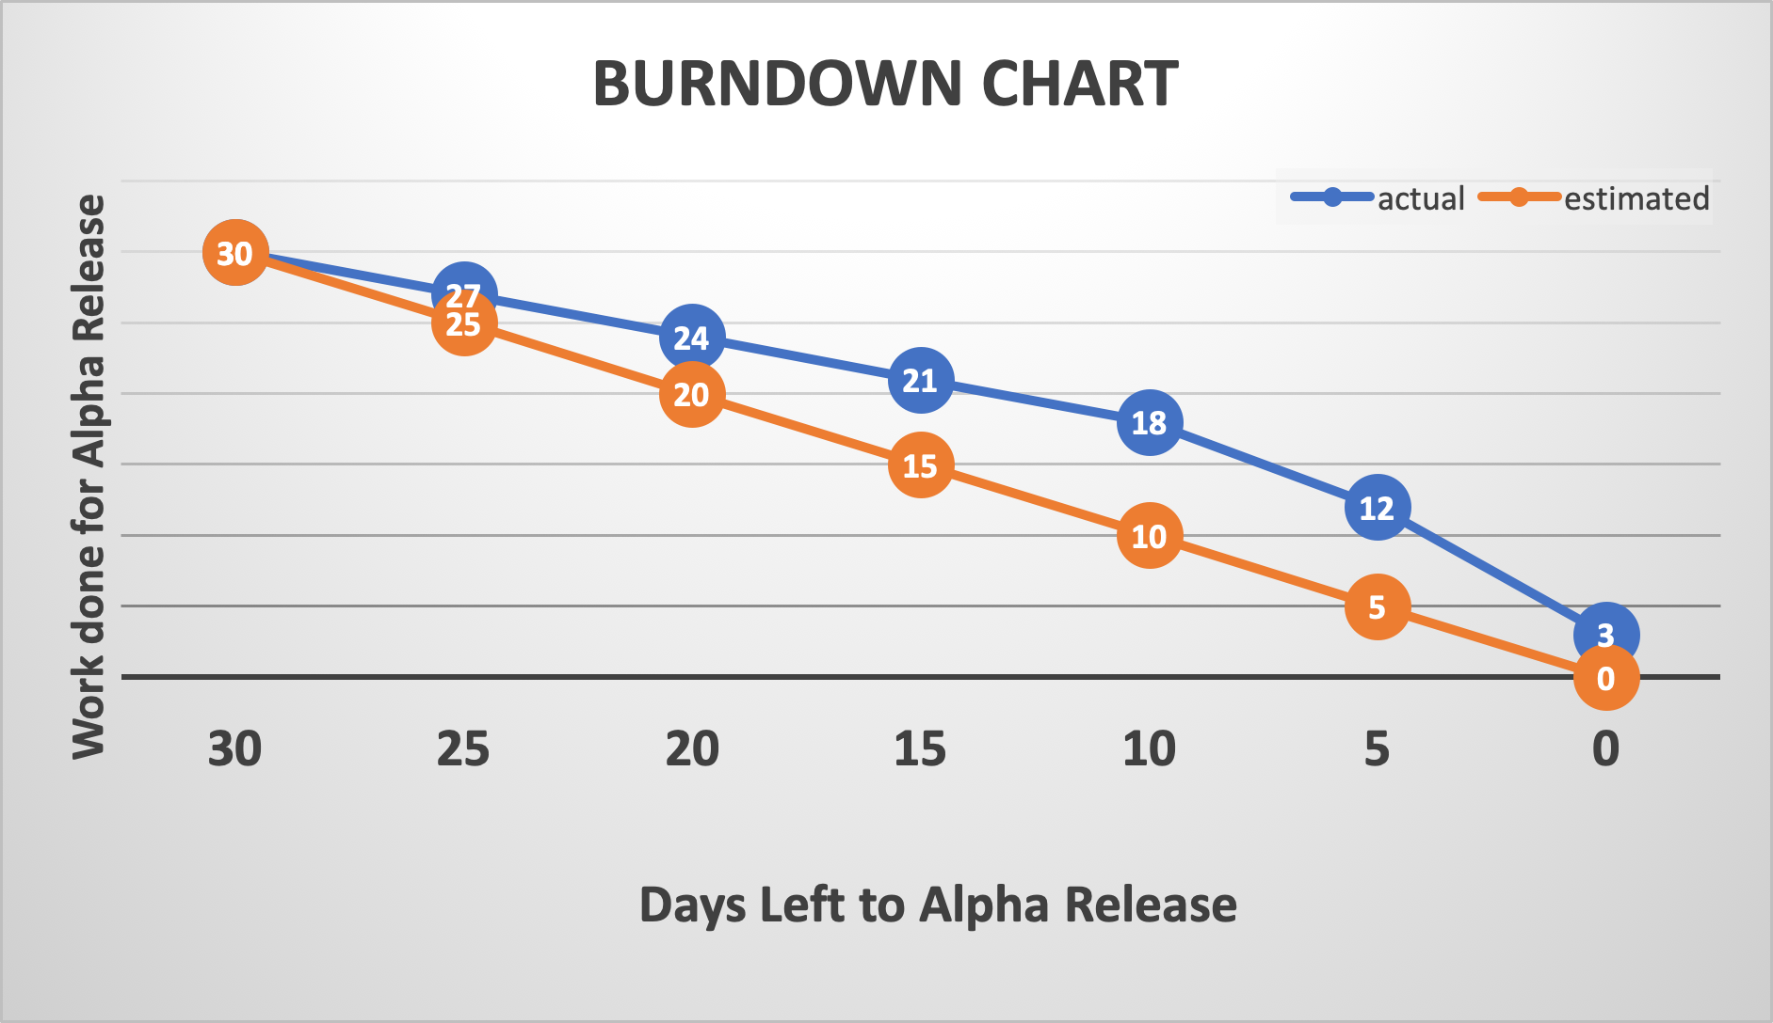

**VELOCITY CHART:**

The Velocity Chart is a means by which the teams’ velocity or pace during the Alpha Release was measured.

Alpha Release took six weeks for completion and in represented on the X-Axis. The achievement of work is shown on the Y-Axis. The pace of the team is found to be constant during the first four weeks, as it was planned that the team members would work an average of 2.5 days in a week and about 5 hours a day. But during the last two weeks the pace increases in order to meet the client testing deadline.

In Alpha, there were 6 User Stories to be Completed over a total time span of 30 days. But, only 3 user stories, that were to be completed in 18 days could be delivered.

The Formula for calculating the velocity of the team is: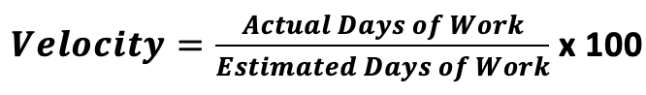

Therefore the velocity of this team is (18/30)*100 = **60%**

It is planned to achieve a least of 70% velocity rate for the Beta and Final Release.

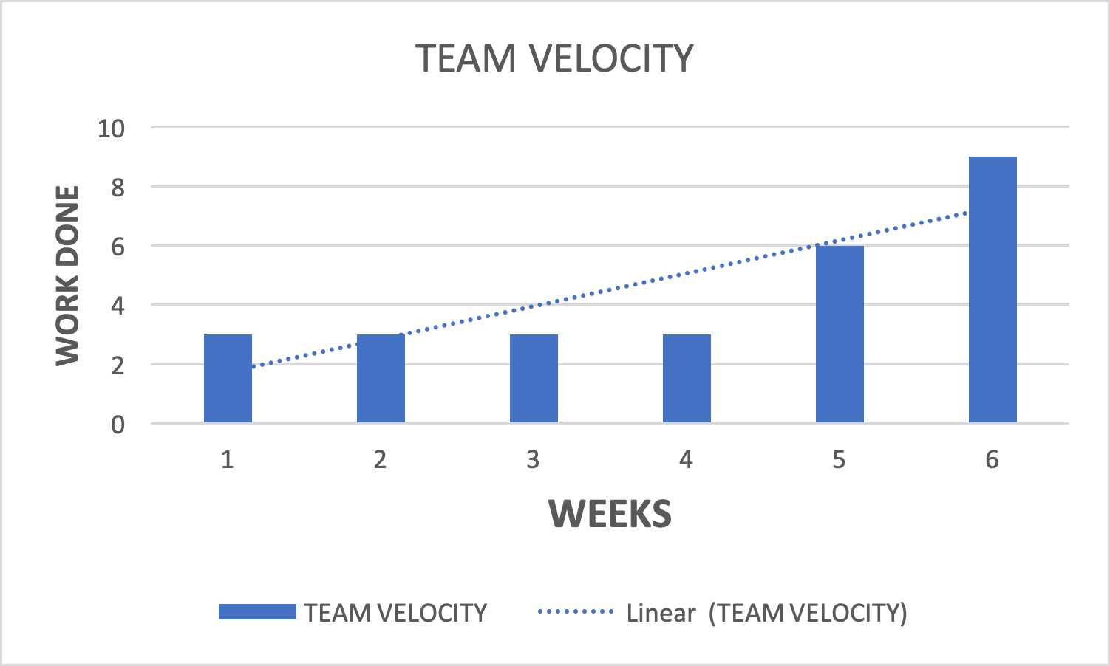

## Beta release prototypes

|  |
| --- |
| User story: Payment page |
|  |
|  |
|  |
| User story: Why we |
|  |
|  |
| User story: Contact us |
|  |
|  |
| User story: Dashboard |
|  |
| User story: Enrolment |
|  |

User stories:

* Dashboard
* Enrolment
* Confirmation
* Subject selection

Would be created by using Moodle external service. It means that the prototypes would be provided by Moodle.

# ICT infrastructure

## Configuration management

Server and Domain

|  |  |
| --- | --- |
| **Subdomain:** | [romashka.ictatjcub.com](http://romashka.ictatjcub.com/) |
| **FTP host:** | [ftp.ictatjcub.com](http://ftp.ictatjcub.com/) |
| **FTP username:** | [romashka@ictatjcub.com](mailto:romashka@ictatjcub.com) |
| **FTP password:** | 123zxcA! |
| **Remote phpMyAdmin:** | [romashka.ictatjcub.com/phpmyadmin](http://romashka.ictatjcub.com/phpmyadmin) |
| **Database name:** | ictatjcu_romashka |
| **Database host:** | localhost |
| **Database user:** | ictatjcu_romashk |
| **Database password:** | 123zxc |

Github

|  |
| --- |
| GitHub is an online version control service which stores our work in versioned fashion. We can revert to any version at any point in time. Multiple users can use a repository to store their work. |
| Link to the repository is as follow:  <https://github.com/harshup96/Romashka> |
|  |
|  |
|  |

Adobe Dreamweaver:

|  |
| --- |
| It is a comprehensive tool developed by Adobe for web designers. We used Dreamweaver for designing our HTML and CSS pages. The integration with Git makes it flawless. It also supports JavaScript, PhP. |
|  |

PHP

|  |
| --- |
| PHP is a server-side scripting language that is embedded in HTML. It is integrated with number of popular databases like MySQL, Oracle, PostgreSQL, Informix, etc. |
|  |
|  |
|  |
|  |
|  |

HTML

|  |
| --- |
| HTML stands for Hypertext Markup Language. It supports tags for various elements of a web page. |
|  |

CSS:

|  |
| --- |
| It is basically a styling language and works in tandem with HTML to create beautiful pages. |
|  |
|  |

** If a new team member adds up in later phases, they have to install Dreamweaver, Access on their laptops. The previously developed versions can be found on GitHub. The new team member should understand our progress and be able to learn programming needed. He/she should be able to understand the user stories and priorities.

**THE DATABASE:**

The remote database for this project is located at ‘romashka.ictatjcub.com/phpmyadmin’.

phpMyAdmin is an open source toll that provides a Graphical User Interface to work with the MySQL database management system in case of this project. With phpMyAdmin, the admin can create, alter or drop databases and tables, create or remove users and user accounts, manage the privileges granted to a particular user, import and export data in SQL and other formats, etc.

For this project, a Database named ‘ictatjcu_romashka’ was created. The Username is ‘ictatjcu_romashk’ and Password is ‘123zxc’. Knowledge of these credentials are sufficient for existing members of the team and any plausible new members who may join the team.

Steps for set-up of Database:

**Step 1: Login**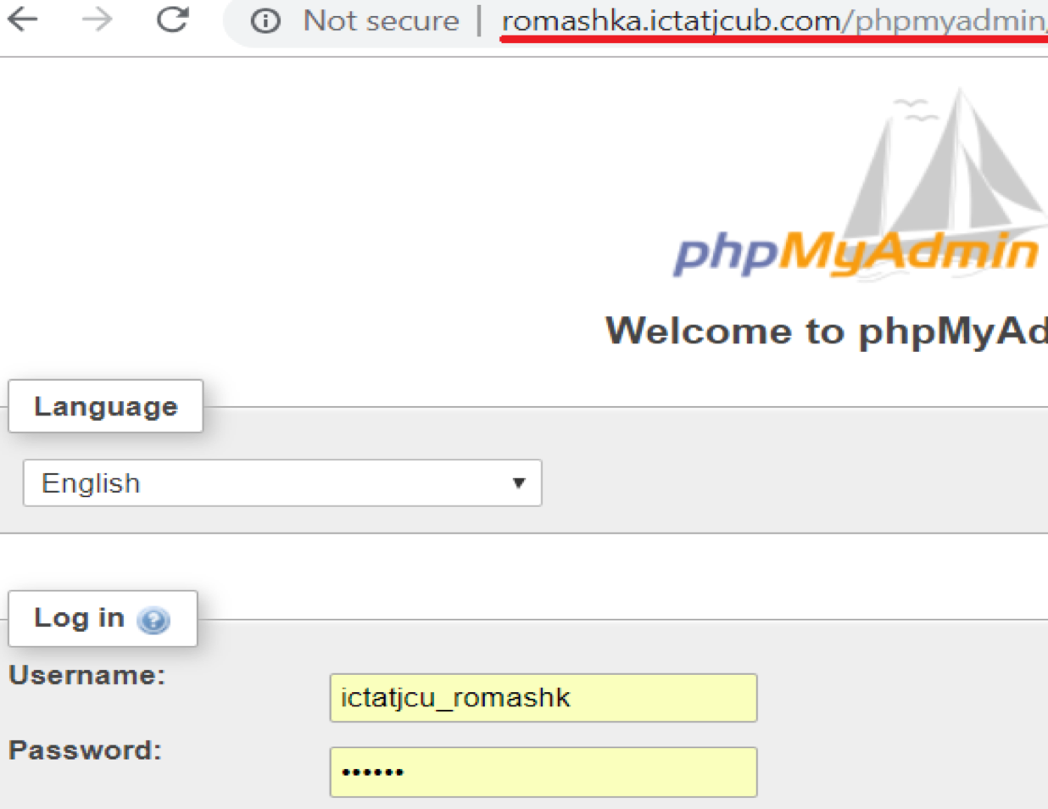

**Step 2: Create Tables and Insert Data (Since Database is already created)**

Tables can be created using SQL or by clicking on the ‘+New’ button on the left hand side.

Similarly, data can be inserted using the Insert tab or by writing an SQL, or my Importing or Exporting from other existing databases, or Excel files.

The Table Columns and data can be seen or edited by selecting the respective table on the side bar. Also, the Primary keys, foreign keys, indexes and relationships can be updated under the ‘Designer’ tab.

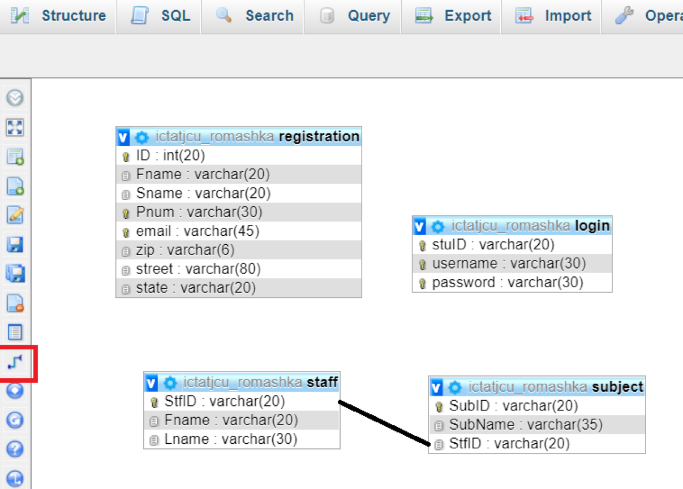

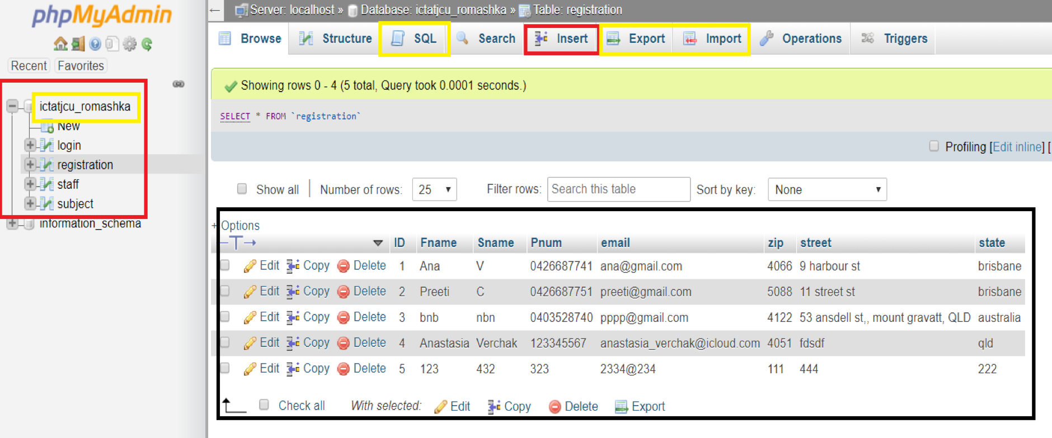

**Step 3: Creating a connection with the database.**

A config.php file contains the php code to enables connection with the database, is included in the <?php> .. ?> section of all the .php files created in the front end of the project.

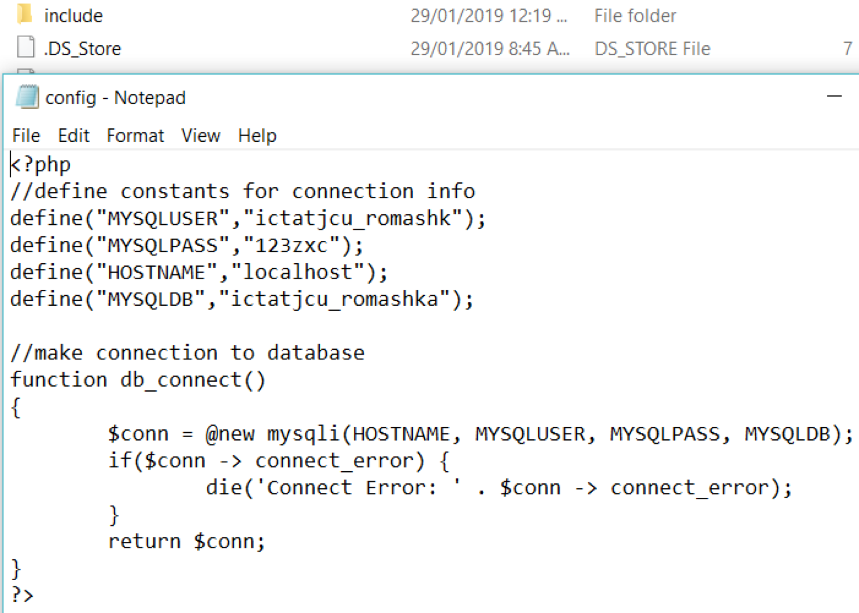

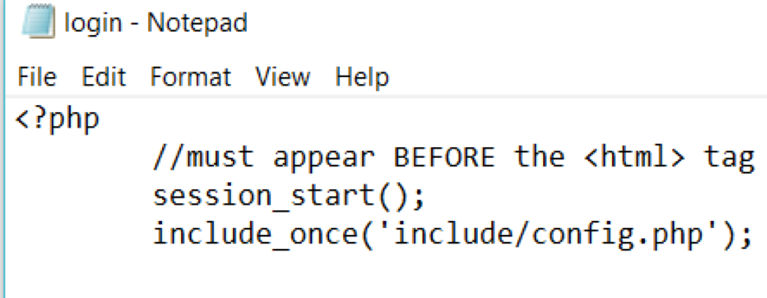

Once the connection is established, suitable php code is inserted in the dynamic pages of the site to for validation and other functionality.

An Example of the Registration.php code is as follows: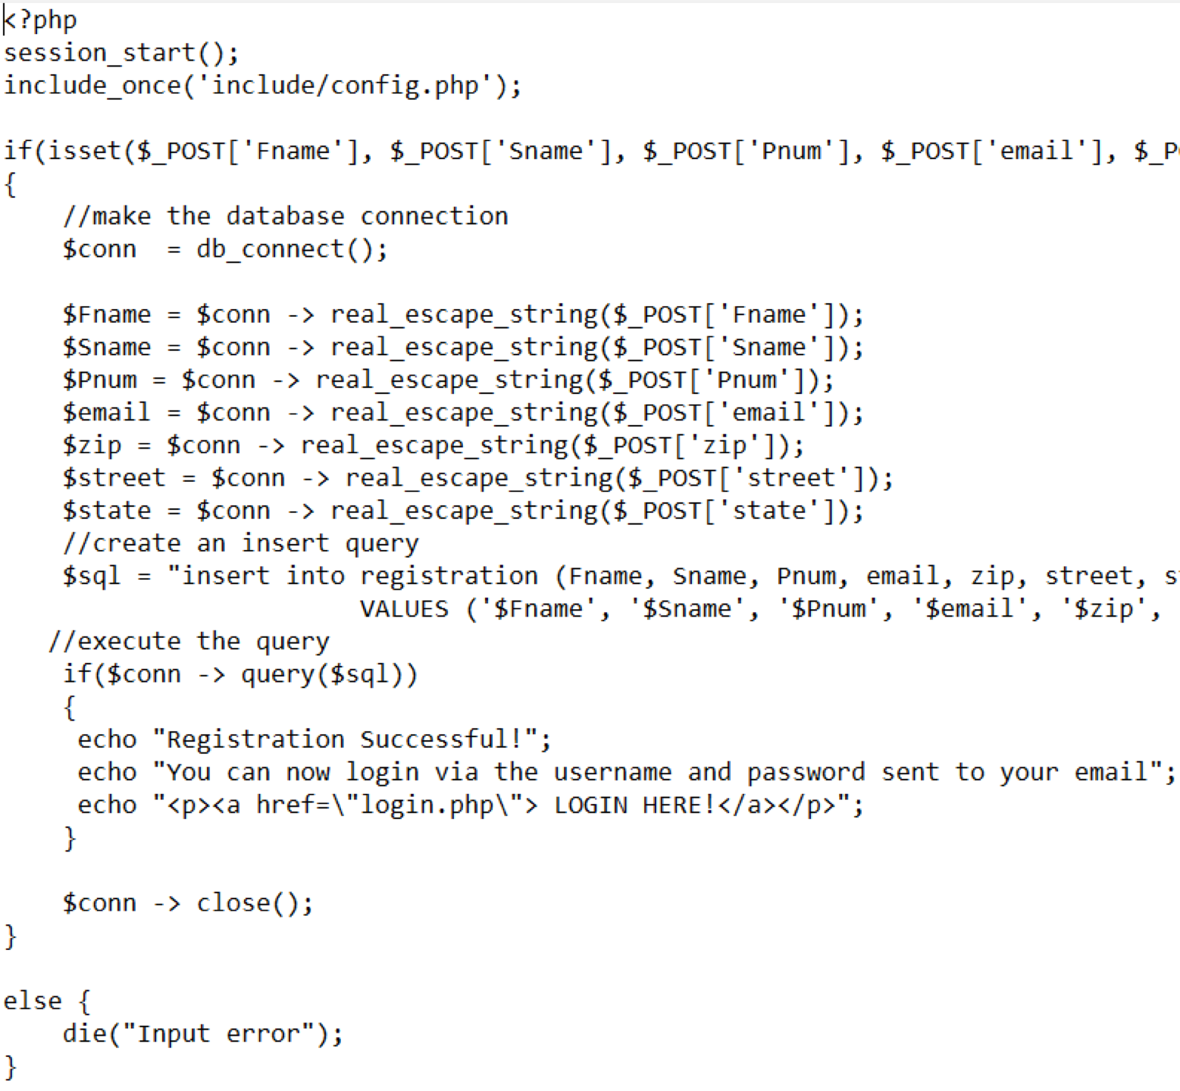

**THE RELEASE ENVIRONMENT**

The Release Environment chosen for this project is ‘WinSCP’. It is an open source FTP client, SFTP client, SCP client, etc. for Windows OS. Its main functionality is File Transfer between a local and a remote computer.

It provides a GUI and is integrated with Windows to provide basic operations with files and drag & drop facilities. For this project, its support with FTP protocols is utilised. It is faster compared to other hosting environments.

How to set-up the environment:

**Step 1:**

On launching WinSCP after installation, it prompts us to login.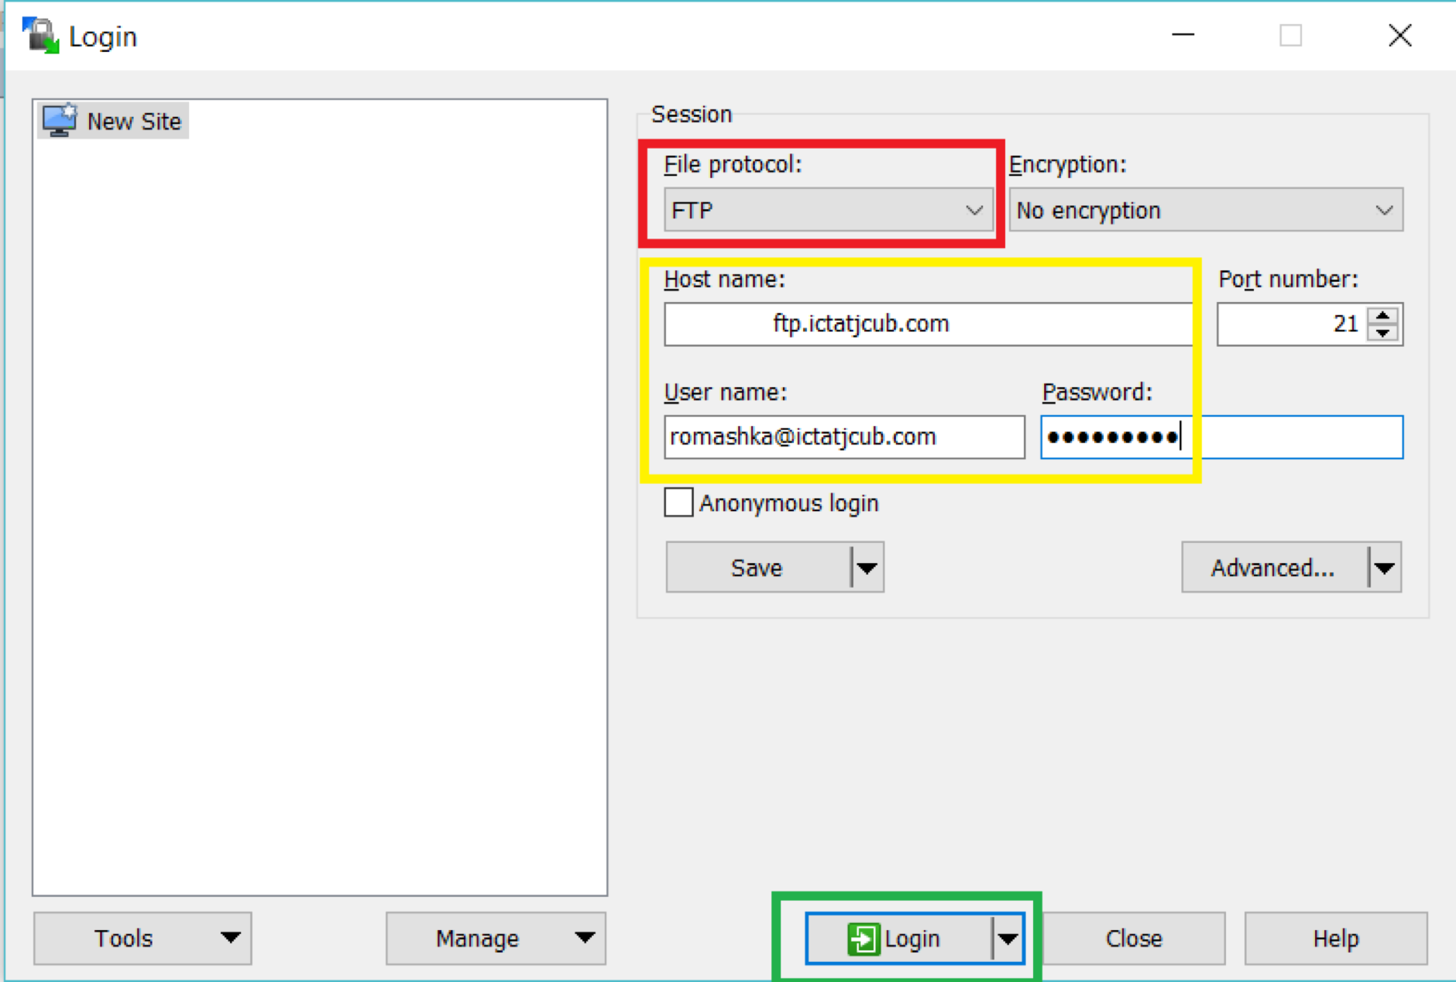

We use the hostname, host username and host password as the credentials to login, but before that, the File Protocol must be set to FTP.

For this project, the host credentials are as under: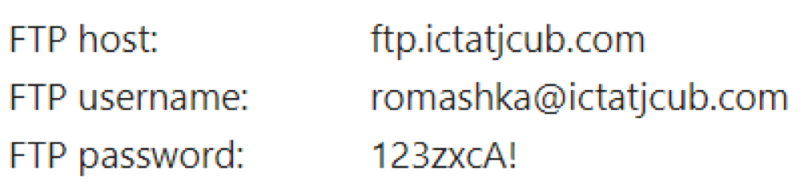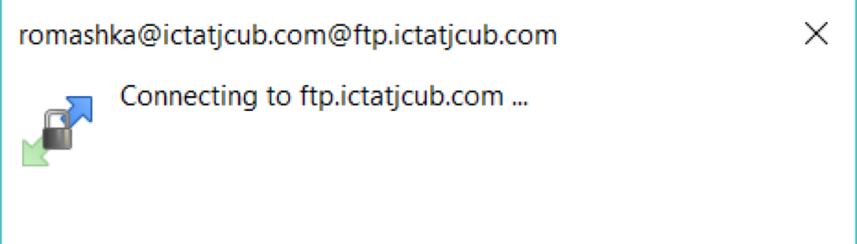

When this dialogue box pops-up, it means the connection is getting established, and if successful the session is started.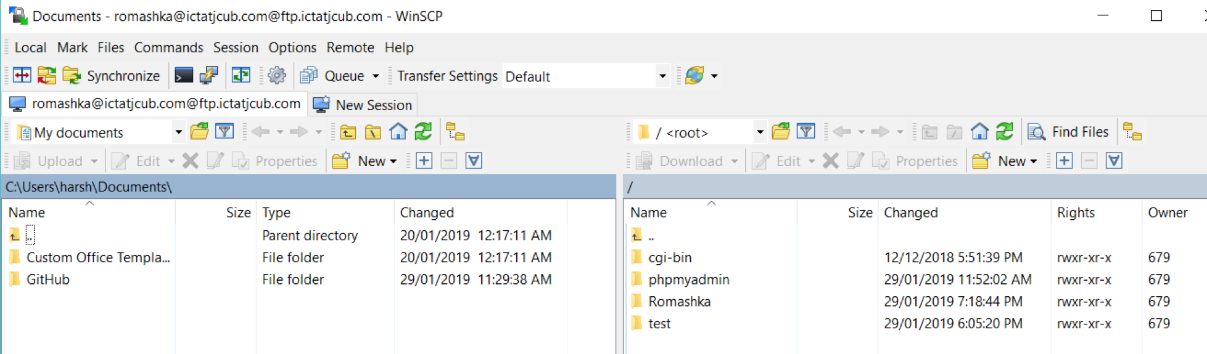

On the left-hand side are the files of the local computer and on the right-hand side are the files on the remote computer.

**Step 2: Perform File Transfer**

The files of the website are all place in a folder name ‘Romashka’. We can simply drag these files from the left hand side of the screen (local PC) and drop them into the right-hand side, the remote computer.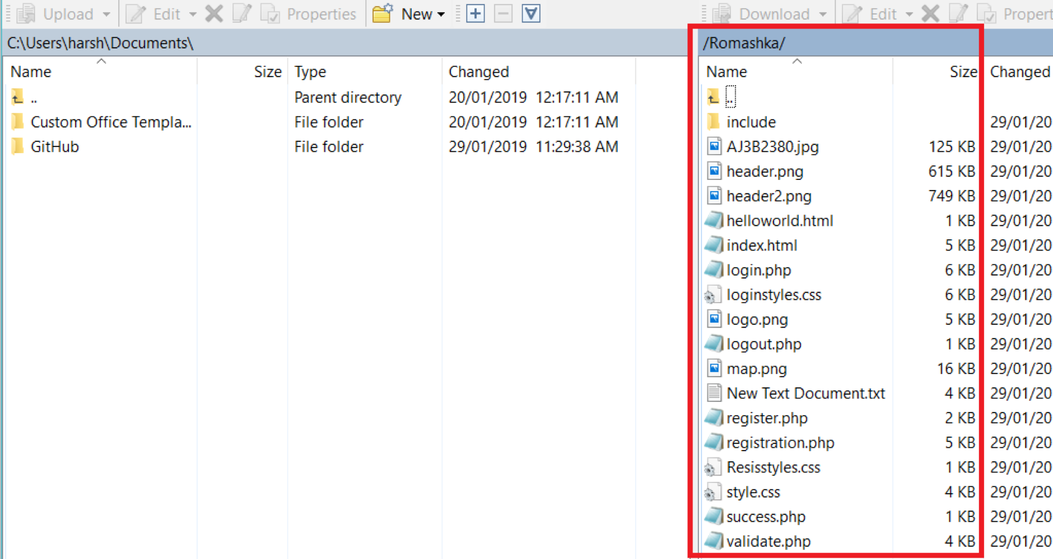

**Step 3: Ready for the Client to test**

The files or the website is now on the remote server and can be tested by the client.

The URL for the client to go to the website is: <http://romashka.ictatjcub.com/Romashka/index.html> or simply <http://romashka.ictatjcub.com/Romashka>, because the hosting environment is configured to look for index files from the folder and run them automatically.

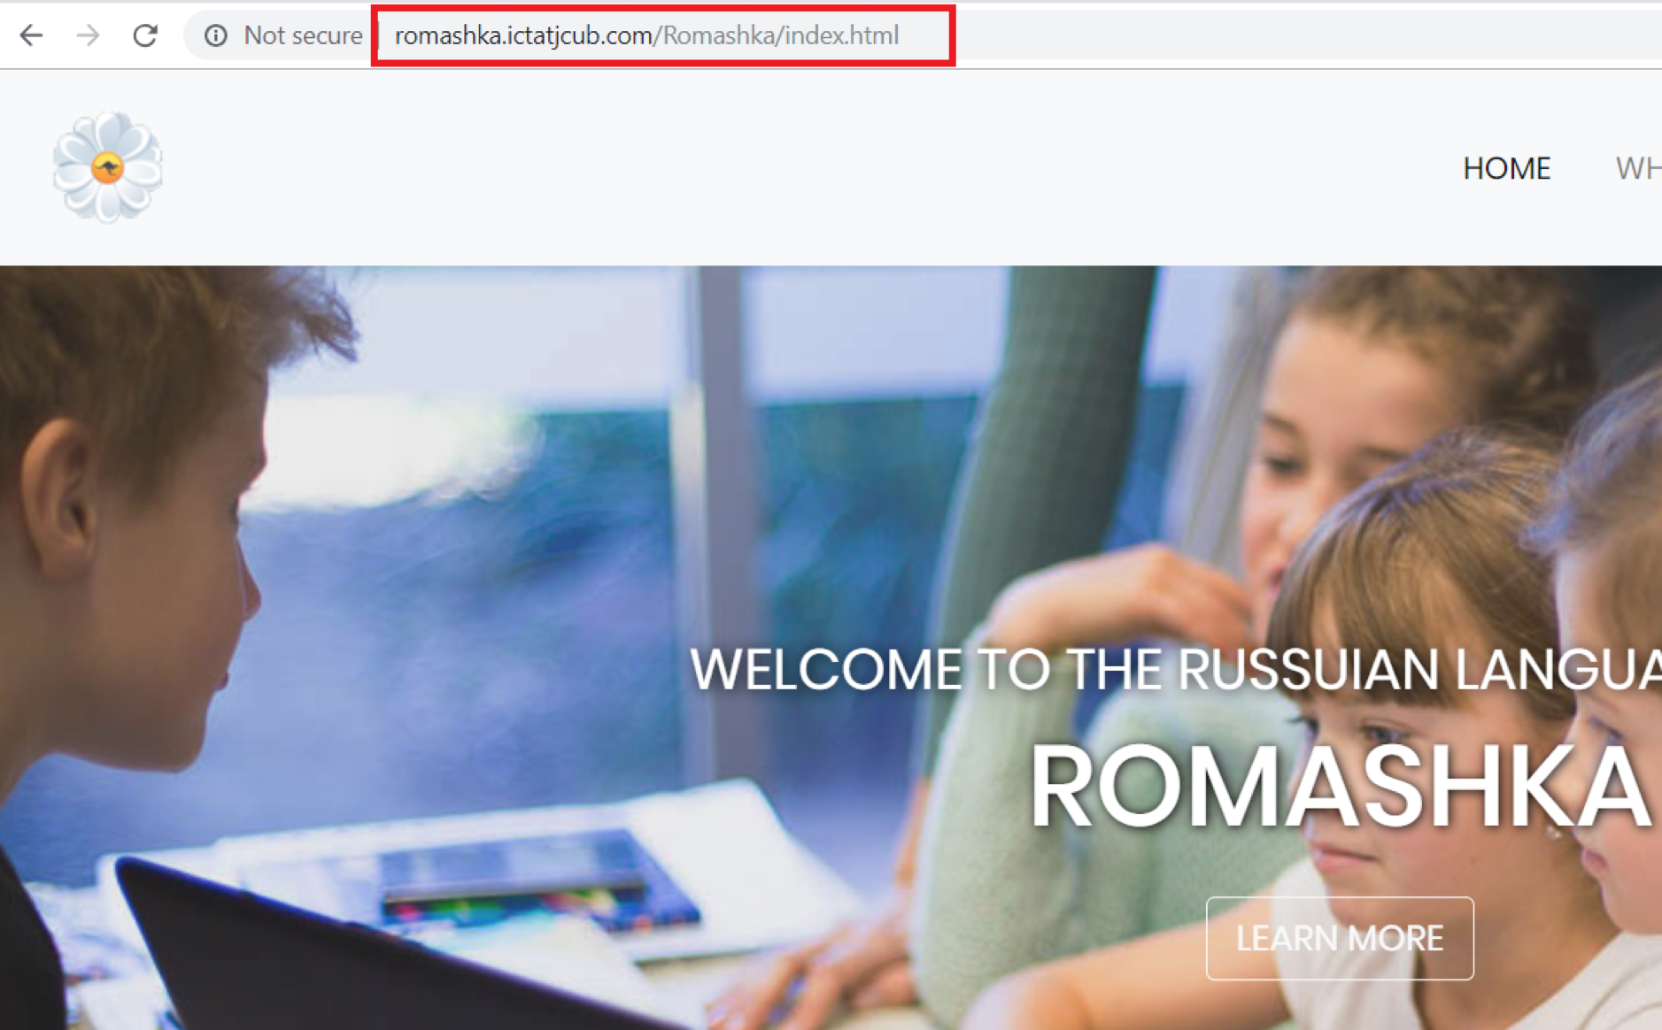

Any changes to the files can me made locally and re-uploaded to the remote hosting environment with no hustle.

Sometimes, due to inactivity or shutting down of the local PC, WinSCP logs out automatically for security purposes and in such cases, a login is necessary and the work can be picked up from where it was last left.

Project management tools

Project management - it is the process of achieving a particular goal within a given framework (time, budget, etc.). At the same time, the concept of PM also includes a set of tools, techniques, skills and techniques that are used to achieve the goal and can vary depending on the changing conditions in which the work is carried out (the appearance of both risks and opportunities).

Trello

Trello is a web-based collaboration service that can help organise and manage projects using cards.  
The main advantage of Trello can be called viewing several simultaneously running projects and their status at the moment. To work with a group of developers or other artists working on projects with deadlines or goals, this system can give an idea of the progress of projects.

In Trello, the emphasis is on packs of cards. Each pack shows the status of any project. For example, if select a team to work, then in the first column there will be cards with a things which has to be done, in the second - tasks in progress, in the third there may be ready tasks, in the fourth - meetings and other general things.  
Cards have many features. They are intended for discussions, polls, download files and data. It is possible to set deadlines, assign text and color labels. To assign an executer to any task, it is necessary to select it in the card from the list of work team or simply drag the executer’s avatar to the task on the right.  
It is important to note that all team members see changes in real time and can monitor the status of individual executers — online or offline.  
Trello is available both in the web interface and as an application for the iPhone. On the iPad, the service works similarly to a desktop implementation.

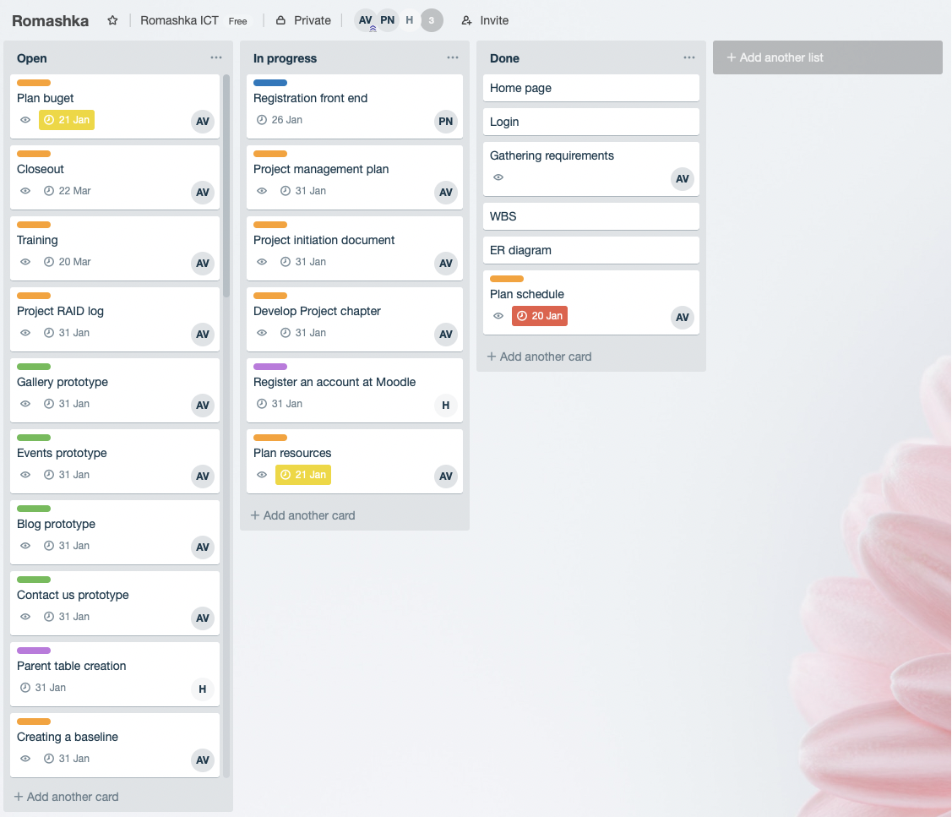

Slack

Slack is an online service for correspondence within the team and a large company, but in fact it is a replacement for Skype for such conversations. This service has the ability to closely integrate active dialogs with other applications. This principle allows you to monitor the progress of work on various projects using one interface and remove unnecessary information.

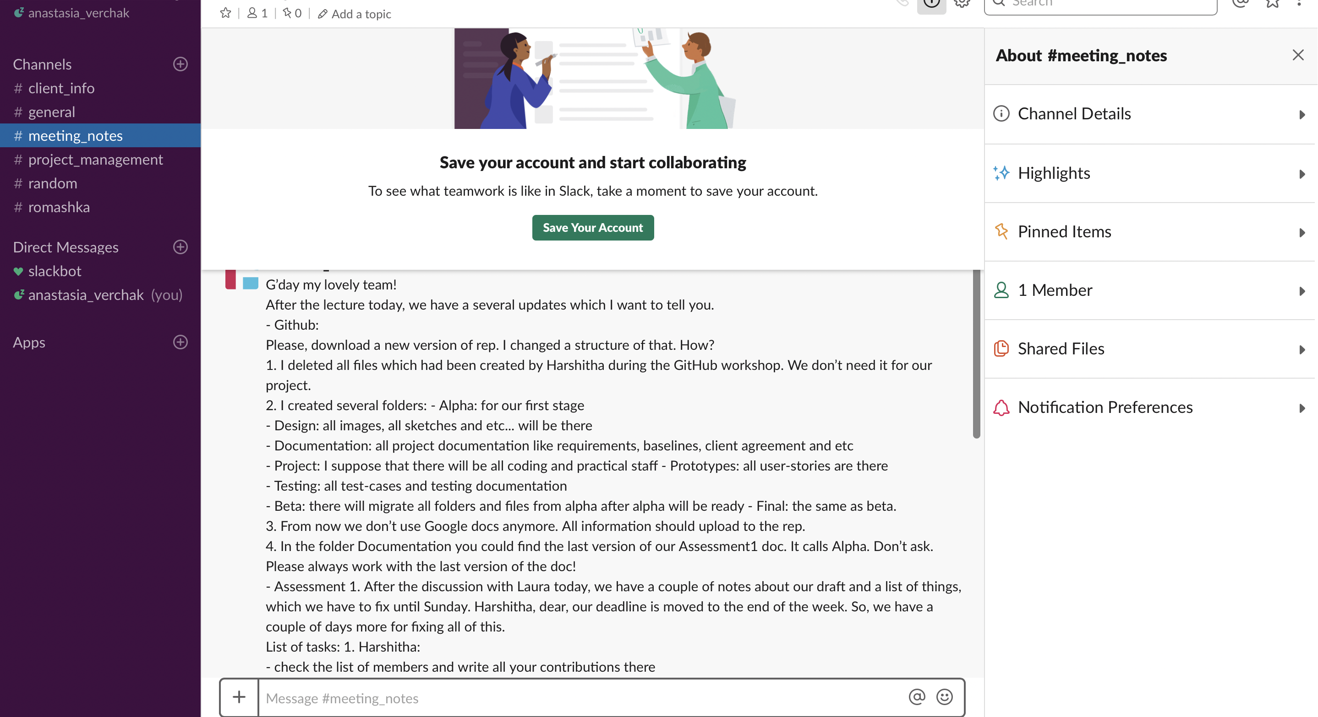

GanttPro

GanttPro - Gantt chart that allows project manager to plan and manage projects online, visualise processes, create tasks and assign them to participants, set deadlines and percentage of individual tasks and the project as a whole, add milestones and share the created Gantt schedule with the team and with clients with the right to view or edit.

Conclusion

In conclusion, Alpha stage have been finished by Team on time and most of the user stories were delivered with good results after the client testing. However, that stage was not easy for the team mainly because of a lot of challenges, which the team met during the cycle. A lot of things have been learnt and the team is definitely prepared for the next stage.